# **SINGAPORE – MALAYSIA ONE WEEK ITINERARY**

28th December – 3rd January

**Accomodations:** ALL HOUSE BOOKINGS VIA [AGODA](https://www.agoda.com) WEBSITE

**Total Flight Costs: 50000/ Person (see image below)**

1. Mangalore to Malaysia – 28th Dec
2. Malaysia to Bali – 31st Dec
3. Bali to Mangalore – 5th Jan

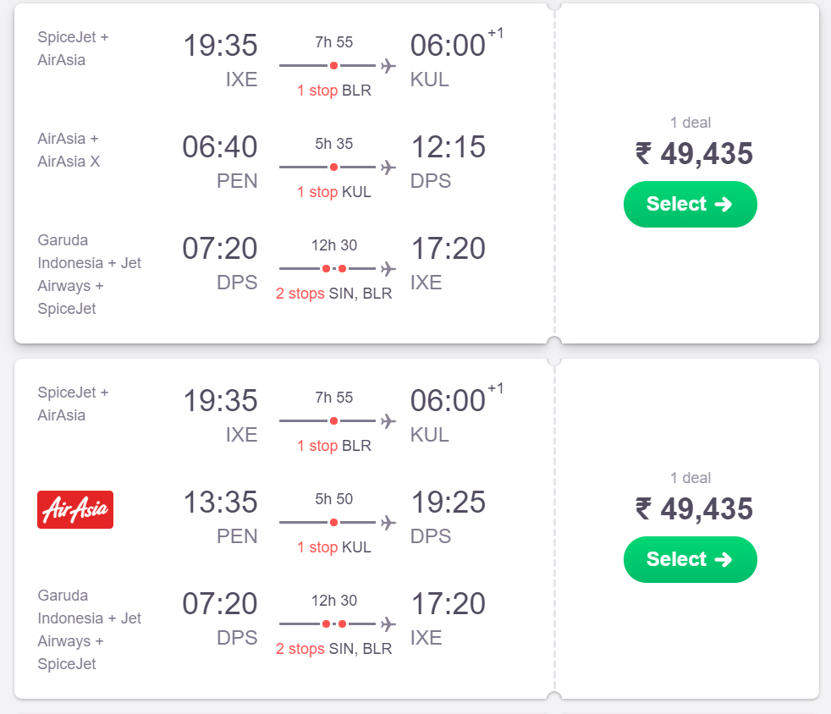

**Day 1**

**Kuala Lumpur- Historic city with modern face**

* Dataran Merdeka (Independence Square).
* Visit the historic St. Mary’s Anglican Cathedral.
* Walk around the streets of Jalan Tun Perak.
* Explore Lebuh Ampang: Pre-war colonial buildings and Masjid Jamek.
* Chinatown at Petaling Street is nearby and an ideal place for some great food and shopping. Walking the Petaling Street is a must.
* Spend your evening at Bukit Bintang, the shopping, and entertainment district of Kuala Lumpur.
* You can also take the Free guided heritage walk (2 hours) organized by Tourism Office in the mornings.

**Day 2**

**Kuala Lumpur- Batu Caves and Menara KL or/and the****Petronas Tower (need online booking)**

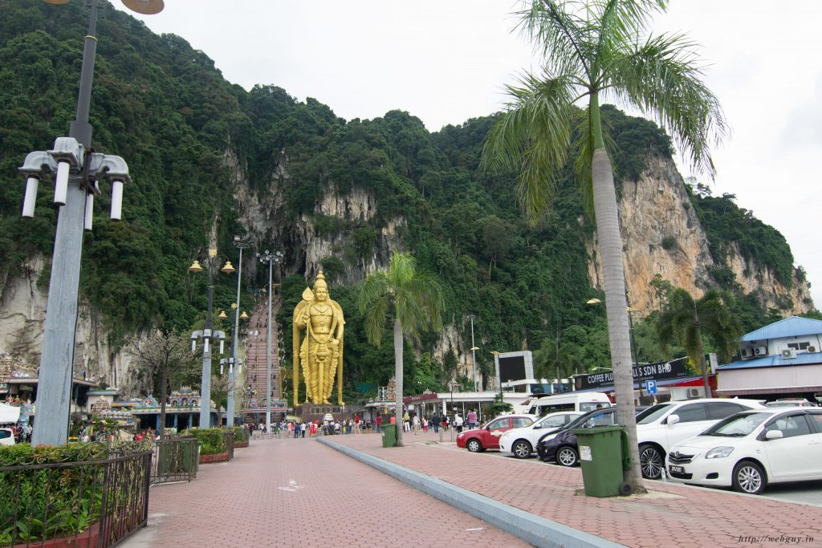

*Batu Caves – Kuala Lumpur, Malaysia*

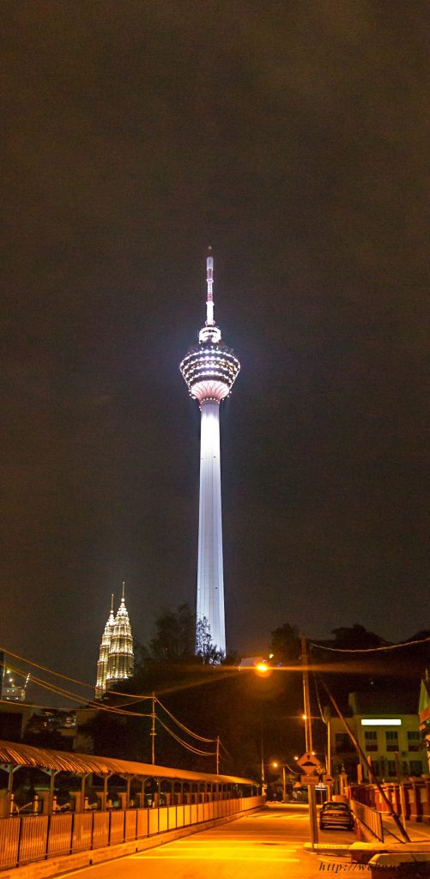

*Petronas Towers*

**Day 3 and 4**

**Kuala Lumpur to Penang using the Commuter Train**

* Explore Georgetown UNESCO Heritage Area.
* Pre-war colonial buildings.
* The famous [street art of George Town](https://webguy.in/2017/04/02/street-art-in-george-town-penang-malaysia/).
* Clan Jetties at Weld Quay.
* Visit the Camera Museum.
* The 3D Interactive Art Museum.
* Take trishaw rides and explore the Armenian street, Little or, just wander around.
* Take a [guided tour of The Blue Mansion](https://webguy.in/2017/04/10/the-tour-that-never-happened/) – an 800-year-old Chinese House

# ALTERNATIVE 1: SINGAPORE

**Day 5**

**Take a bus to Singapore.**

* Walk around in the Marina Bay area.
* Visit Merlion for a customary picture.
* Watch the light show in Gardens By The Bay.
* Watch the light show at Marina Bay.
* Street food near Marina Bay.

OR

* A boat cruise would cover the above.

## Day 6

On second day in Singapore:

* Go shopping on Orchard road or Bugis.
* Visit the bird park or Singapore zoo – the zoo here is pretty good.
* Visit Sentosa Island (Madame Tussaud’s, 4D World, and Wings of Time) and experience**the Universal studio (**10 AM**–**2 PM), the SEA  Aquarium (4 PM – 6 PM), Wings of time (7:40 PM).

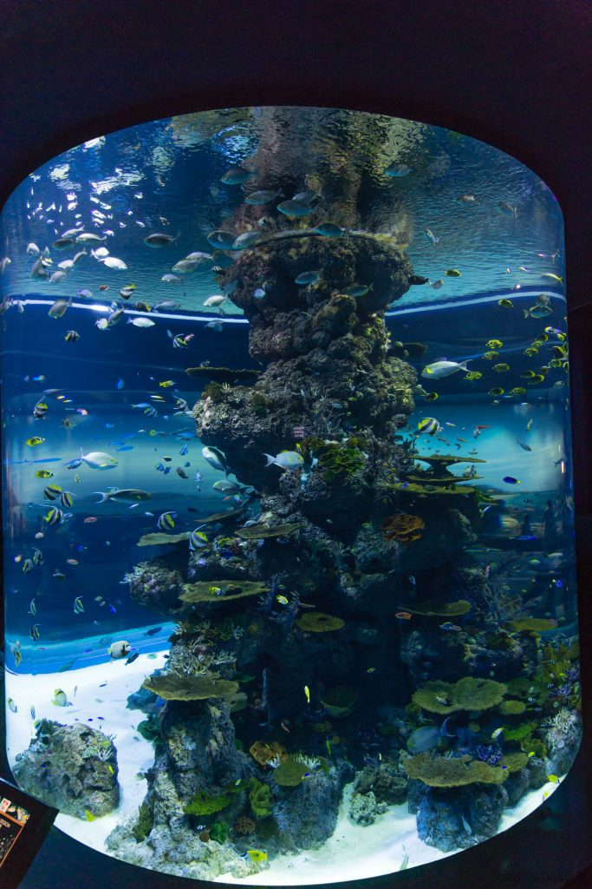

## Day 7 and 8

On your day of departure, before heading to the airport, visit the following:

* Explore Little India.
* Explore and Shop in China Town.
* Walk in and around Arab Street and sample mouthwatering delicacies.
* Leave for the airport.

# ALTERNATIVE 2: BALI, INDONESIA

**TRAVEL:**

The main form of public transportation in Bali is the bemo (a van or minibus). Fares are fixed, however, tourists are usually overcharged. Bear in mind that the bemo won’t leave until full and local language expertise is required.

Other travel options:

* Bluebird taxis (they’re a light blue colour with a blue bird on the roof). They are the safest and will always run the meter.
* Download go jek, which is like an Indonesian Uber type app.
* Savings are higher by [**RENTING A CAR HERE**](https://www.klook.com/activity/800-private-car-charter-bali/?aid=480).

**ACCOMODATION:**

**Head north** – The southern area of Bali (Kuta, Ubud, Seminyak, etc) is the most popular and most expensive part of the island. If you head to the beaches in the north or northeast part of Bali, you’ll find that prices are about half the cost and you’ll be able to find better deals on accommodation.

**FOOD:**

Local food is extremely cheap, usually under 10,000 IDR for street food. A basic local meal will cost closer to 15,000 IDR. Western food is a lot more expensive but is still affordable at around 125,000 IDR. Fast food will cost around 60,000 IDR while a beer at the bar will be around 23,000 IDR. A bottle of water will be under 5,000 IDR.

Indonesian foods are generally Chinese influenced, but if you want to try authentic Balinese or Indonesian dishes, head to a warung or food carts. Many Balinese dishes require some time to cook, two of the must-try food here is babi guling (spit-roasted suckling pig) and betutu bebek (duck roasted in banana leaves).

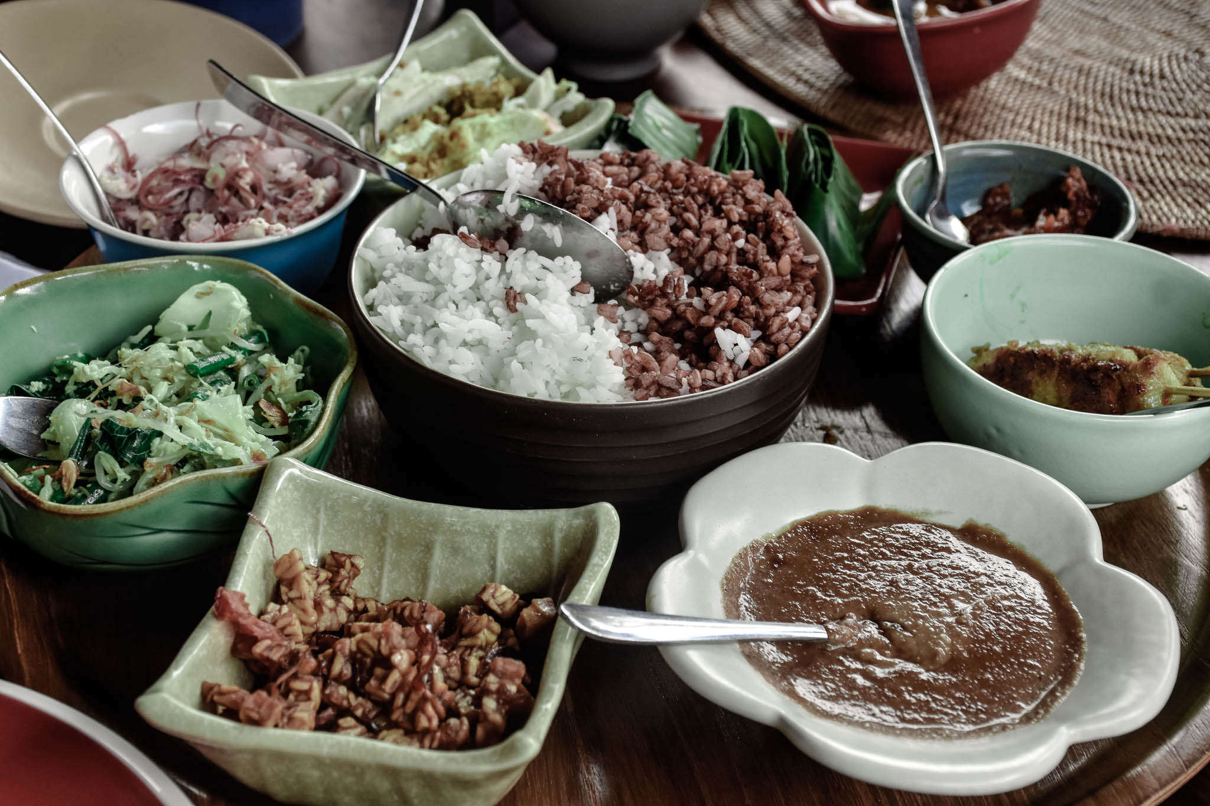

**Plan of Activities:**

Here’s a sample Bali Itinerary for 4 days 3 nights.

Day 1 and Day 3:  For [**BALI CAR RENTAL, BOOK HERE.**](https://www.klook.com/activity/800-private-car-charter-bali/?aid=480)Day 2: For [**BALI TOUR, BOOK HERE.**](https://www.klook.com/activity/150-balis-greatest-hits-bali/?aid=480) I checked and it seems to be very affordable.

Feel free to modify this depending on your trip schedule and budget. The calculations are done for 5 people based on current rates on the above websites.

|  |
| --- |
|  |
|  | **EXPENSES** | **ACTIVITIES** |
| **DAY 5** |  | **ULUWATU TOUR** |
| 04:00 AM |  | ETD Bali from Penang (31st dec) |
| 07: 50 AM | INR 470 | Arrival in Bali. Airport to Hotel Transfer. Car Rental. |
| 09:30 AM | INR 2650 | Check-in at hotel. Freshen up. |
| 09:00 AM | INR 5220 | Start of Uluwatu Tour via Car rental: **Nusa Dua Luxury Beach, Peninsula Beach, Nusa Dua Water Blow** |
| 11:30 PM | INR 1250 | Lunch 250/person |
| 12:30 PM |  | Continue Uluwatu Tour: **Virgin Beach, Dreamland Beach, Pandawa Beach, Padang Padang Beach.** |
| 05:00 PM | INR 400 | Explore **Uluwatu Temple**. 100/person |
| 06:00 PM | INR 2500 | **Kecak Dance** 500/person |
| 08:30 PM |  | Back to Hotel. Dinner. Shop for souvenirs. |
| 10:00 pm |  | Sleep. |
| **DAY 6** |  | **Central Bali Tour** |
| 07:30 AM | INR 1250 | Breakfast 250/person |
| 8:30 AM |  | Hotel pick-up |
| 9:00 AM | INR 4110 | Start of Bali Tour via tour package with Klook. **Batubalan for Barong Dance Performance, Celuk Village (gold & silver smiths) and Mas Village (wood carving)** |
| 11:30 AM |  | Kintamani for lunch w/ **Mt. Batur** views |
| 12:30 PM |  | Continue Bali Tour: **Tirta Empul Temple & Holy Springs, Gunung Kawi Royal Monument and Tegallalang Rice Terraces** |
| 06:00 PM |  | End of Tour. Back to hotel. Freshen up. |
| 07:00 PM | INR 1250 | Dinner. Explore nightlife in Bali. |
| 10:00 PM | INR 2650 | Back to Hotel. Sleep. |
| **DAY 7** |  | **West Bali Tour (Bedugul)** |
| 07: 30 AM | INR 1250 | Breakfast |
| 8:00 AM | INR 2336 | West Bali Tour via car rental |
| 8:30 AM | INR 1000 | West Bali Tour: **Jatiwuluh Rice Terraces, Taman Ayun Temple** |
| 11:30 AM | INR 1250 | Lunch |
|  | INR 750 (IDR 30,000) | Continue Bedugul Tour: **Ulun Danu Temple, Twin Lake** |
| 05:00 PM |  | Sunset watching at **Tanah Lot Temple** |
| 06:30 PM | INR 2800 (IDR 133,000) | Back to Hotel. |
| 8:00 PM | INR 1250 | Dinner. Socials. |
| 10:00 PM |  | Sleep. |
| **DAY 8** |  |  |
| 5:00 AM |  | Check out. Airport Transfer |
|  |  |  |
| **TOTAL** | **INR 32,386** | INR 8096.5 / person |
|  |  |  |

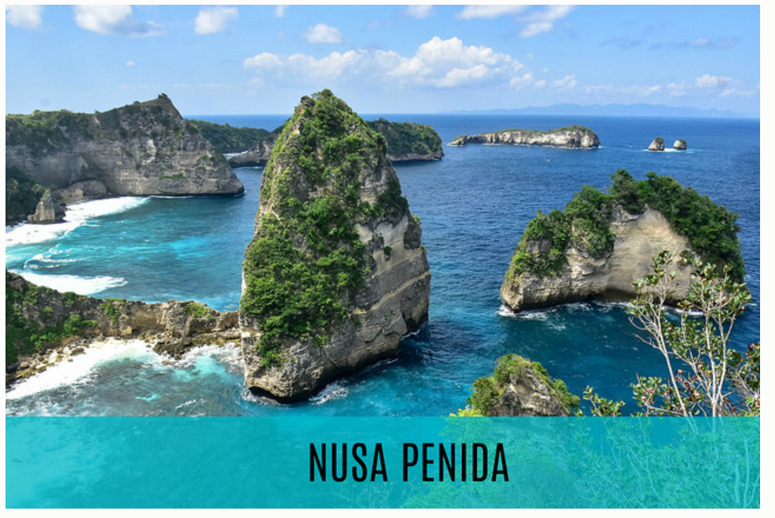

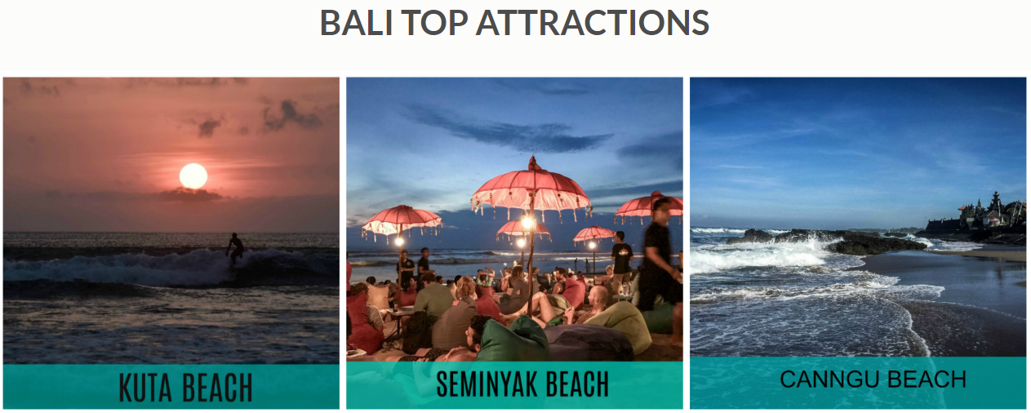

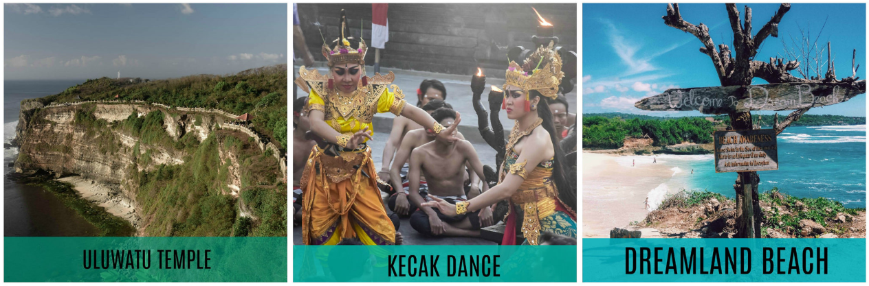

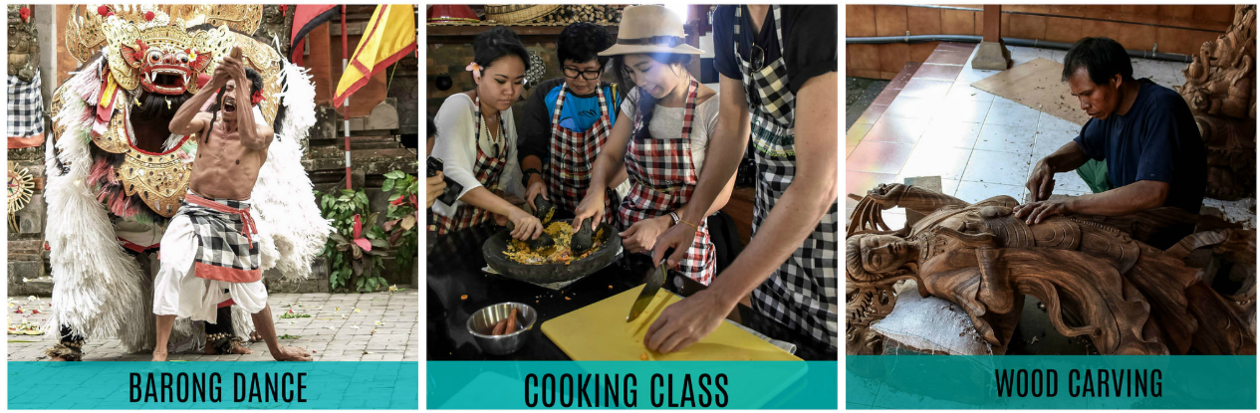

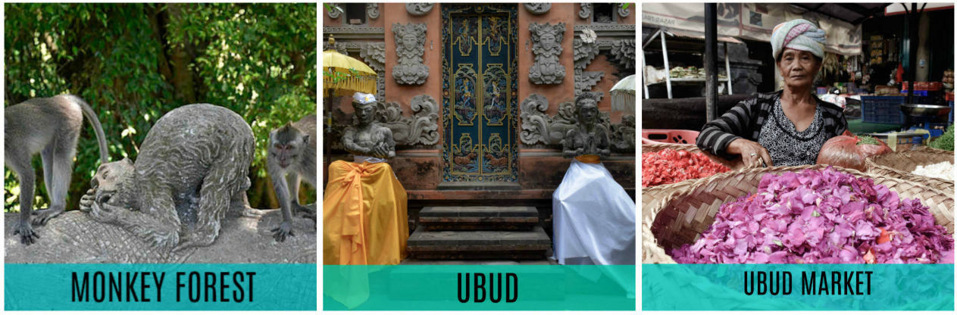

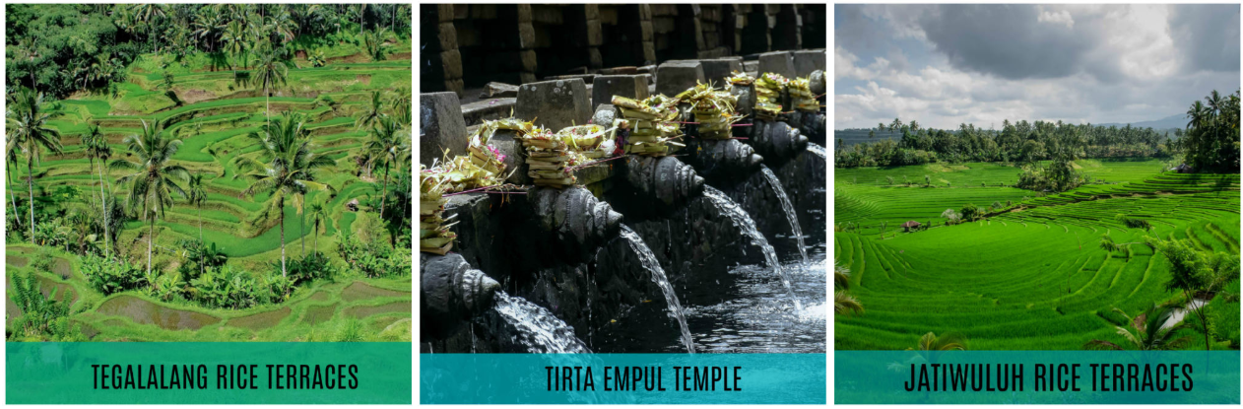

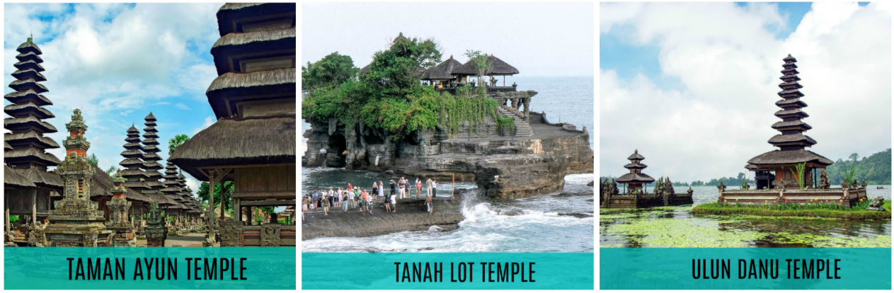

## BALI HELPFUL TIPS FOR FIRST-TIMERS

1. Dress and act modestly when visiting temples. A sarong or a scarf is handy to cover up; however, the most-visited ones like Uluwatu usually have them for visitors to borrow.
2. Take off your shoes when entering a house.
3. Always have a sarong with you in Bali as most temples require you to wear one either male or female.
4. Do not step on the offerings at doorsteps and gates which are usually small fragrant parcels made of palm leaves, incense and flowers
5. Avoid touching a person’s head. The Balinese believe that the head is the most sacred part of the body.
6. Always use your right hand when eating, receiving or giving something.  Using the left hand is believed to be disrespectful.
7. There were reports of motorcycle-riding thieves in Seminyak and Kuta area. So please be careful with your phones and handbags. Be mindful of your things and surroundings while walking.